**NAME :RUSSEL LOBO**

**SAP ID: 60004190098**

**BATCH – TE /B3**

**SUBJECT- SOFTWARE ENGINEERING**

**SAPID:** 60004200082, 60004200066

**Names:** Pratham Bhoir, Aayushman Gupta

**Batch:** A2

**Experiment No. 1**

**Aim:** To identify a suitable life cycle model for your case study and justify your choice

**MindPrep**

**ABSTRACT**

Online teaching has imposed great challenges for student engagement during the pandemic. Building a virtual classroom with active student participation is our approach to address some of the concerns and make online learning more effective.  As technology creates remote and global teams, all users must be able to connect. Our E-learning management system application, MindPrep provides all that the modern education system requires, such as a unified conversation platform where team members can have an open chat, voice, and video calls with optimal call quality and collaboration through content sharing. MindPrep is a single product that also offers a complete meeting solution, supporting sharing materials, voice, and video conferencing, allowing users to meet from anywhere. Users can use this application for all types of meeting -– spontaneous or scheduled; formal or informal with internal and external participants; along with sharing and submitting materials as per requirements.

MindPrep is introduced as a virtual study room with many virtual tables (channels), where each table (channel) serves as an integrated platform for group meetings. Within this application , Learner-learner interaction is boosted by virtual meetings, group poster boards, the “mention” function, and emojis. By integrating it with video conferencing, we can offer a zero blackout, fully interactive learning environment. The paper includes a detailed description of the required technologies for such a delivery, time requirements for the design and delivery of such an approach, and faculty assessment and perspective of the methodology.

**FEATURES:**

**MindPrep features make it stand out from other collaboration software:**

1. **Teams and channels**: Teams are made up of channels, which are conversation boards between teammates.
2. **Conversations within channels and teams**: All team members can view and add to different conversations in the General channel and can use an @ function to invite other members to different conversations.
3. **A chat function**: The basic chat function is commonly found within most collaboration apps and can take place between teams, groups, and individuals.
4. **Document storage in CloundShare :** Every team who uses MindPrep will have a site in CloundShare Online, which will contain a default document library folder. All files shared across all conversations will automatically save to this folder. Permissions and security options can also be customized for sensitive information.
5. **Online video calling and screen sharing:**  Enjoy seamless and fast video calls to employees within your business or clients outside your business. A good video call feature is great to have on a collaboration platform. One can also enjoy simple and fast desktop sharing for technical assistance and multi-user real-time collaboration.
6. **Online meetings:** This feature can help enhance your communications, company-wide meetings, and even training with an online meetings function that can host up to 10,000 users. Online meetings can include anyone outside or inside a business. This feature also includes a scheduling aid, a note-taking app, file uploading, and in-meeting chat messaging.
7. **Audio conferencing:** This is a feature you won’t find in many collaboration platforms. With audio conferencing, anyone can join an online meeting via phone. With a dial-in number that spans hundreds of cities, even users that are on the go can participate with no internet required. Note this requires additional licensing.
8. **Full telephony:** That’s right! The days of seeking VoIP vendors and overspending on a phone system are finally over. Microsoft  365 Business Voice can completely replace your business’ existing phone system. Note this requires additional licensing.

**Life Cycle for MindPrep:**

One of the potential lifecycle model for our MindPrep application is **Spiral Model** for the following reasons listed below:

* **Flexibility**: New features can be added easily in the later versions hence making our model flexible for updates.
* **Large projects:** MindPrep is a large project covering several micro-features thus spiral methods seems to be fit for our application.
* **Risk Management**: MindPrep has many micro-services thus having many possible point of failure like Technical risks or Business risks, making this model robust, when business needs may be unstable.

However, Spiral Model have certain disadvantages

* **Risk Management**: Risk analysis requires highly specific expertise which is costly and resource exhaustive in the initial stages of development.
* **Delayed Testing:** Testing is carried out at the end of the engineering phase, thereby, delaying the product launch in Alpha and Beta phases and updating the bugs simultaneously.
* **Re-usability:** Services in the application need to be re-used while spiral supports reusability only up to some extent.
* **Comprehensive Documentation:** It focuses on comprehensive documentation while MindPrep being a customer-oriented application simpler documentation is required.
* **Time Management:** Difficulty in time management. As the number of phases is unknown at the start of the project, so time estimation is very difficult.
* **Expensive:** Can be a costly model to use.

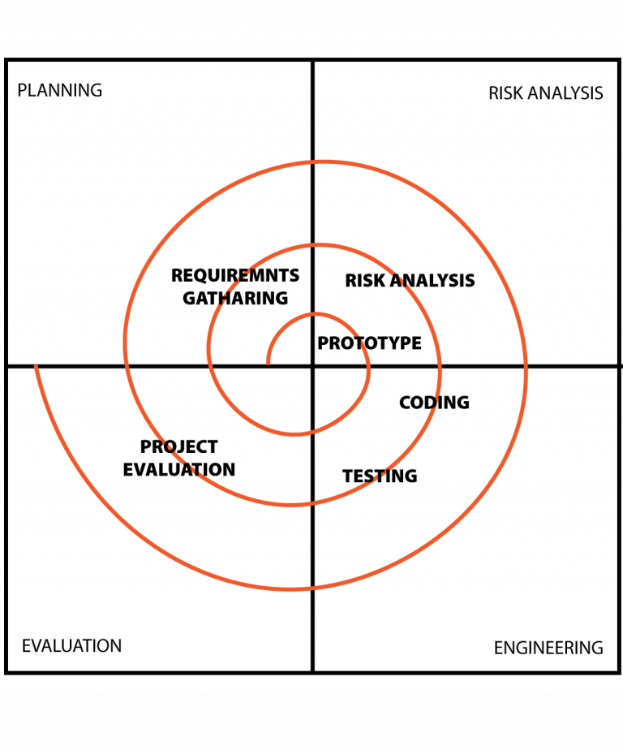

Finally, we propose to use **Agility Scrum** as the development work is partitioned into “packets” and the testing and documentation are on-going as the product is constructed.

The key features of the aforementioned model:

* Small working team is used to maximize communication, minimize overhead, and maximize sharing of informal knowledge thus, engaging only related employees at a time.
* Process is adaptable to both technical and business risks to ensure smoother flow while development.
* Provides the ability to launch the product whenever required, thereby, allowing us to launch alpha/beta version so as to have a source of income while simultaneously working on the application.
* Scrum focuses on continuously taking feedback from the end user and implementing the updates. Thus, making our application more robust to bugs and glitches i.e. based on Demos (deliver software increment to customer for evaluation)
* Development work and team involved are partitioned into appropriate sub-domains for faster execution within the stipulated time.
* Testing and documentation is performed as the product is built thereby, allowing us to deploy the core features initially and then built on the additional features as per the success of the application.
* Sprints (work units required to achieve one of the backlog items, must fit into a predefined time-box, affected backlog items frozen)
* Scrum meetings (15 minute daily meetings) addressing these questions: What was done since last meeting? What obstacles were encountered? What will be done by the next meeting?

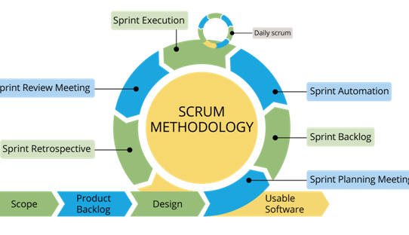

**CONCLUSION:**

In this experiment we understood the different life cycle models and their suitability in different scenarios. We chose the **Agility Scrum model** because testing and documentation is performed simultaneously as the product is developed thereby, allowing us to deploy the core features initially and then built on the additional features as per the success of the application. MindPrep being an end-user based application also requires continuous feedback from the end-users to make the application more user friendly and robust to bugs and glitches. Using Scrum model new features can be built into the product in subsequent sprints and also can be modified based on stakeholder’s or customer feedbacks between sprints. Scrum model focuses on shorter scrum meetings engaging only the related employees thereby, blocking less resources and maximising the efficiency which is much economically beneficial for the application maintenance.

**SAPID:** 60004200082, 60004200066

**Names:** Pratham Bhoir, Aayushman Gupta

**Batch:** A2

**Experiment No. 2**

**Aim:** To develop Software Requirement Specification (SRS) document in IEEE format

for the project.

**Theory: SRS Software Requirements Specification**

A document that specifies most of the requirements as required by the customer and as

understood by the software engineer.

A well formatted document that includes scope, purpose, product perspective, software

and hardware requirements, functional and non-functional requirements for the product.

**Performance:**

1. Identify a suitable case study with the scope for software engineering process.

2. Explain the abstract in one page clearly explaining the project with their

functionalities.

3. Each project should have at least 4 functional requirements clearly explaining

each functionality by referring to the given SRS template.

4. Prepare a well-formatted document

**Conclusion:**

In this experiment we were able to make an SRS for our case study and clearly

understood the process and requirements for an SRS.

**Software Requirements Specification**

**for**

**MindPrep E-Learning Management System**

**Version 1.0**

**Prepared by,**

**Group Name: MindPrep**

|  |  |  |
| --- | --- | --- |
| **Pratham Bhoir** | **60004200082** | **prthmbhr28@gmail.com** |
| **Aayushman Gupta** | **60004200066** | **guptaaayushmaan@gmail.com** |
|  |  |  |
|  |  |  |

|  |  |
| --- | --- |
| **Instructor:** | **Prof. Kiran Bhowmick** |
| **Course:** | **Software Engineering** |
| **Lab Section:** | **A2** |
| **Teaching Assistant:** | **Prof. Kiran Bhowmick** |
|  |  |

**Contents**

**Revisions** [**iii**](https://docs.google.com/document/d/1BDWS8KmMXxmVvPHHrLkz0RHLwpWzsL0Xm7kzMYZzwv8/edit#heading=h.30j0zll)

**1** **Introduction** [**1**](https://docs.google.com/document/d/1BDWS8KmMXxmVvPHHrLkz0RHLwpWzsL0Xm7kzMYZzwv8/edit#heading=h.tyjcwt)

1.1 Document Purpose [1](https://docs.google.com/document/d/1BDWS8KmMXxmVvPHHrLkz0RHLwpWzsL0Xm7kzMYZzwv8/edit#heading=h.3dy6vkm)

1.2 Product Scope [1](https://docs.google.com/document/d/1BDWS8KmMXxmVvPHHrLkz0RHLwpWzsL0Xm7kzMYZzwv8/edit#heading=h.1t3h5sf)

1.3 Intended Audience and Document Overview [1](https://docs.google.com/document/d/1BDWS8KmMXxmVvPHHrLkz0RHLwpWzsL0Xm7kzMYZzwv8/edit#heading=h.4d34og8)

1.4 Definitions, Acronyms and Abbreviations [1](https://docs.google.com/document/d/1BDWS8KmMXxmVvPHHrLkz0RHLwpWzsL0Xm7kzMYZzwv8/edit#heading=h.2s8eyo1)

1.5 Document Conventions [1](https://docs.google.com/document/d/12EvL00SArn3QTXTxGv0mejNxpfhtXLQS/edit#heading=h.17dp8vu)

1.6 References and Acknowledgments [2](https://docs.google.com/document/d/1BDWS8KmMXxmVvPHHrLkz0RHLwpWzsL0Xm7kzMYZzwv8/edit#heading=h.3rdcrjn)

**2** **Overall Description** [**3**](https://docs.google.com/document/d/1BDWS8KmMXxmVvPHHrLkz0RHLwpWzsL0Xm7kzMYZzwv8/edit#heading=h.26in1rg)

2.1 Product Perspective [3](https://docs.google.com/document/d/1BDWS8KmMXxmVvPHHrLkz0RHLwpWzsL0Xm7kzMYZzwv8/edit#heading=h.lnxbz9)

2.2 Product Functionality [3](https://docs.google.com/document/d/1BDWS8KmMXxmVvPHHrLkz0RHLwpWzsL0Xm7kzMYZzwv8/edit#heading=h.35nkun2)

2.3 Users and Characteristics [3](https://docs.google.com/document/d/1BDWS8KmMXxmVvPHHrLkz0RHLwpWzsL0Xm7kzMYZzwv8/edit#heading=h.1ksv4uv)

2.4 Operating Environment [3](https://docs.google.com/document/d/1BDWS8KmMXxmVvPHHrLkz0RHLwpWzsL0Xm7kzMYZzwv8/edit#heading=h.44sinio)

2.5 Design and Implementation Constraints [4](https://docs.google.com/document/d/1BDWS8KmMXxmVvPHHrLkz0RHLwpWzsL0Xm7kzMYZzwv8/edit#heading=h.2jxsxqh)

2.6 User Documentation [4](https://docs.google.com/document/d/1BDWS8KmMXxmVvPHHrLkz0RHLwpWzsL0Xm7kzMYZzwv8/edit#heading=h.z337ya)

2.7 Assumptions and Dependencies [4](https://docs.google.com/document/d/1BDWS8KmMXxmVvPHHrLkz0RHLwpWzsL0Xm7kzMYZzwv8/edit#heading=h.3j2qqm3)

**3** **Specific Requirements** [**5**](https://docs.google.com/document/d/1BDWS8KmMXxmVvPHHrLkz0RHLwpWzsL0Xm7kzMYZzwv8/edit#heading=h.1y810tw)

3.1 External Interface Requirements [5](https://docs.google.com/document/d/1BDWS8KmMXxmVvPHHrLkz0RHLwpWzsL0Xm7kzMYZzwv8/edit#heading=h.4i7ojhp)

3.2 Functional Requirements [6](https://docs.google.com/document/d/1BDWS8KmMXxmVvPHHrLkz0RHLwpWzsL0Xm7kzMYZzwv8/edit#heading=h.2bn6wsx)

3.3 Behaviour Requirements [6](https://docs.google.com/document/d/1BDWS8KmMXxmVvPHHrLkz0RHLwpWzsL0Xm7kzMYZzwv8/edit#heading=h.qsh70q)

**4** **Other Non-functional Requirements** [**7**](https://docs.google.com/document/d/1BDWS8KmMXxmVvPHHrLkz0RHLwpWzsL0Xm7kzMYZzwv8/edit#heading=h.3as4poj)

4.1 Performance Requirements [7](https://docs.google.com/document/d/1BDWS8KmMXxmVvPHHrLkz0RHLwpWzsL0Xm7kzMYZzwv8/edit#heading=h.1pxezwc)

4.2 Safety and Security Requirements [7](https://docs.google.com/document/d/1BDWS8KmMXxmVvPHHrLkz0RHLwpWzsL0Xm7kzMYZzwv8/edit#heading=h.49x2ik5)

4.3 Software Quality Attributes [7](https://docs.google.com/document/d/1BDWS8KmMXxmVvPHHrLkz0RHLwpWzsL0Xm7kzMYZzwv8/edit#heading=h.2p2csry)

**5** **Other Requirements** [**8**](https://docs.google.com/document/d/1BDWS8KmMXxmVvPHHrLkz0RHLwpWzsL0Xm7kzMYZzwv8/edit#heading=h.147n2zr)

**Appendix A – Data Dictionary** [**9**](https://docs.google.com/document/d/1BDWS8KmMXxmVvPHHrLkz0RHLwpWzsL0Xm7kzMYZzwv8/edit#heading=h.23ckvvd)

**Appendix B - Group Log** [**10**](https://docs.google.com/document/d/1BDWS8KmMXxmVvPHHrLkz0RHLwpWzsL0Xm7kzMYZzwv8/edit#heading=h.ihv636)

**Revisions**

| **Version** | **Primary Author(s)** | **Description of Version** | **Date Completed** |
| --- | --- | --- | --- |
| 1 | Pratham Bhoir,  Aayushman Gupta | The current version of SRS is a comprehensive description of the MindPrep application and the proposed design of the same. | 07/04/23 |

1. **Introduction**

Online teaching has imposed great challenges for student engagement during the pandemic. Building a virtual classroom with active student participation is our approach to address some of the concerns and make online learning more effective.  As technology creates remote and global teams, all users must be able to connect. Our E-learning management system application, MindPrep provides all that the modern education system requires, such as a unified conversation platform where team members can have an open chat, voice, and video calls with optimal call quality and collaboration through content sharing. MindPrep is a single product that also offers a complete meeting solution, supporting sharing materials, voice, and video conferencing, allowing users to meet from anywhere. Users can use this application for all types of meeting -– spontaneous or scheduled; formal or informal with internal and external participants; along with sharing and submitting materials as per requirements.

MindPrep is introduced as a virtual study room with many virtual tables (channels), where each table (channel) serves as an integrated platform for group meetings. Within this application , Learner-learner interaction is boosted by virtual meetings, group poster boards, the “mention” function, and emojis. By integrating it with video conferencing, we can offer a zero blackout, fully interactive learning environment. The paper includes a detailed description of the required technologies for such a delivery, time requirements for the design and delivery of such an approach, and faculty assessment and perspective of the methodology.

1. **Document Purpose**

The purpose of this SRS document is to define the requirements and scope of our MindPrep application being created in full detail. On top of outlining all functional and nonfunctional requirements, it will also go into depth about different use cases. This SRS will also contain any models that were used in the making of the software, as well as a description of the prototype that was created.

1. **Product Scope**

MindPrep is a persistent chat-based collaboration platform with document sharing, online meetings, and many more extremely useful features for education and business communications. MindPrep’s mission is to "empower every person and every organization on the planet to achieve more." MindPrep is a tool that helps make that mission statement a reality.

The key objectives of the MindPrep is to **Learn On The Go** that is the ability to take it anywhere. Secondly, providing user-friendly plugins housed in one location. Employees have one place to access important resources quickly. No more clicking between different applications, emails, or company resources in a web of SharePoint sites. LMS software provides employees with a blended learning experience for well-rounded, engaging training. Educational content is presented in a variety of forms: written, audio, videos, etc. to support learning objectives. Easy to track, assess, and report analysis making it easy for teachers and supervisors to track the progress. Streamlining and personalisation of the training process thereby, improving the efficiency and letting employees train at their own pace and ask questions as needed.

1. **Intended Audience and Document Overview**

Our intended audience are the corporate employees of MindPrep, testers , marketing staff, the documentation writers, developers and project managers.

The remaining sections of this document provide a general description, including characteristics of the users of this project, the product's hardware, and the functional and data requirements of the product.  General description of the project is discussed in section 2 of this document.  Section 3 gives the functional requirements, data requirements and constraints and assumptions made while designing the E-LMS (MindPrep).  It also gives the user viewpoint of the product.  Section 3 also gives the specific requirements of the product.  Section 3 also discusses the external interface requirements and gives detailed description of functional requirements. Section 4 is for supporting, non functional information. Section 5 covers any other requirements.

The following SRS contains the detailed product perspective from different stakeholders. It provides the detailed product functions of E-LMS with user characteristics permitted constraints, assumptions and dependencies and requirements subsets.

1. **Definitions, Acronyms and Abbreviations**

**API:**  Application Programming Interface

**ASCII:** American Standard Code for Information Interchange

**CRUD:** Create, Retrieve, Update, and Delete

**CSV:** Comma Separated Value

**HHD:** Hard Disk Drive

**HTML:** HyperText Markup Language

**HTTP:** HyperText Transfer Protocol

**HTTPS:** HTTP Secure

**JSON:** JavaScript Object Notation

**MTBF:** Mean Time between Failures

**MVC:** Model-View-Controller

**NIST:** National Institute of Standards and Technology

**PDF:** Portable Document Format

**QIF:** Quality Information Framework

**REST:** Representational State Transfer

**SRS:** Software Requirements Specification

**SSD:** Solid state drives

**SSL:** Secure Sockets Layer

**TLS:** Transport Layer Security

**UI:** User Interface

**UUID:** Universally Unique Identifier

**VDS:** Volatile Data Stream

**XML:** Extensible Markup Language

**XSLT:** Extensible Stylesheet Lanaguage Transformation

1. **References and Acknowledgments**
2. N. Partheeban and N. SankarRam, "e-Learning management system using web services," International Conference on Information Communication and Embedded Systems (ICICES2014), 2014, pp. 1-7, doi: 10.1109/ICICES.2014.7033900.

1. S. M. Jafari, S. F. Salem, M. S. Moaddab and S. O. Salem, "Learning Management System (LMS) success: An investigation among the university students," 2015 IEEE Conference on e-Learning, e-Management and e-Services (IC3e), 2015, pp. 64-69, doi: 10.1109/IC3e.2015.7403488.
2. A. Al-Ajlan and H. Zedan, "E-learning (MOODLE) based on service oriented architecture", Proceeding of the EADTU's 20th Anniversary Conference, pp. 62-70, Nov. 8–9.
3. E. Ambrosi, M. Bianchi and G. Felici, "When is it convenient to predict the web services completion time?", Proceedings of the 24th IASTED International Conference on Parallel and Distributed Computing and Networks, pp. 250-255, Feb. 14–16.
4. G. Naveh, D. Tubin and N. Pliskin, "Student LMS use and satisfaction in academic institutions: The organizational perspective", The Internet and Higher Education, vol. 13, no. 3, pp. 127-133, 2010.

**2. Overall Description**

* 1. **Product Perspective**

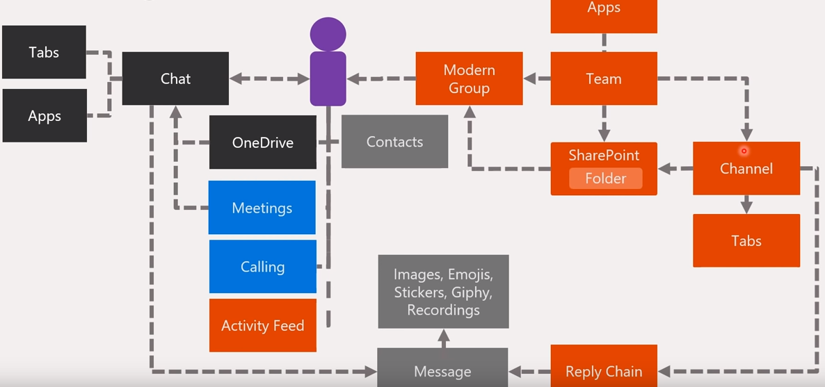

1. **Product Functionality**

MindPrep features make it stand out from other collaboration software:

* Teams and channels
* Chat features enabling conversations within channels and teams
* Document storage in OneDrive
* Online video calling and screen sharing
* Online meetings
* Audio conferencing
* Personalisation for user
* Online file sharing support
* Inbuilt apps (word, excel and ppt) support along additional plugins

1. **Users and Characteristics**

Users of MindPrep can be any person who is interested in having online presentations, meetings or even a conversation. Mainly this would be used for a classroom environment with the goal of conducting online lectures and tests.

Mainly we can categorize the users as Student, Faculty, Management, Admin:

**Student:** Each student can participate in lectures by joining the teams by using a team code provided by the lecturer.Once joined the meet they can view the white board and the presentations real-time while listening to the lecture. They can also interact with the lecturer and the other students without interrupting the lecture and also can participate in online exams the lecturer has given.The students can also store notes of the lectures in one drive.

**Faculty:**A software white board is provided to them in order to demonstrate the lectures. The documentations/presentations can be distributed prior to the lecture. Lecturers can interact with the students by asking and by answering their questions. Lecturers can also conduct an exam by storing a set of questions. Lecturers can also create a class notebook in order to maintain various lab submissions done by students.

**Admin:** As admin, they have the task of maintaining the system such as maintaining the database, performing regular backups, keeping the system running and handling any failure of the system.

1. **Operating Environment**

**Microsoft Teams supports the following operating systems:**

IOS,Android,Windows,Linux,Mac

**Mobile devices such as iPhone, iPad, or Android devices must meet these software requirements:** iPhones/iPads require iOS 11-14 or the future newest iOS version,Android smartphones/tablets require one of the four latest operating systems

**MindPrep works in the following browsers:**

Safari (no calls via Teams possible)

Google Chrome

Mozilla Firefox (no calls via Teams possible)

Opera

MS Edge

**Minimum Hardware requirements  and software requirements for MindPrep:**

**Hardware:**

Computer and processor Minimum 1.1 GHz or faster, 4 core

4-core processor for video calls

4 GB RAM

HDD / SSD 3 GB free disk space

1024 x 768 pixels screen resolution

**Software:**

Graphics card supporting DirectX 9

.NET Framework 4.5 CLR

64-bit Windows for meetings

Windows 8.1 or 10

1. **Design and Implementation Constraints**
2. The browsers must have plug-ins in order to access word,presentations, meetings .
3. Team meetings on browsers are limited to a single stream; either incoming video feed of the current speaker or screen sharing..
4. Number of channels in a team is limited to 45 including deleted channels.
5. Onedrive has to be connected in order to share documents with sharepoints or to create class notebooks and in order to store the notebooks
6. Number of members which a team can have is limited to 500.

1. **User Documentation**

A readme file to help the user with the installation of the software will be provided . A well documented user manual will be provided where a proper demonstration of how to connect your video and audio,how to create teams,schedule meets,schedule tests,create class notebooks and various such topics would be covered . Online tutorials would also be made available on the MindPrep official website.

1. **Assumptions and Dependencies**

It is assumed that our application is compatible with the following dependencies:

1. OneDrive (Version 22.045)
2. Microsoft Office (Version 2021)
3. Agora Websockets (Android v3.6.2 , IOS v3.6.2)
4. Google Calendar API (v3)
5. Quiz Bot (1.2.8.39)

**3. Specific Requirements**

**1. External Interface Requirements**

**1. User Interfaces**

The user interface for the web application is compatible with any browser such as Google Chrome, Internet Explorer, Mozilla or Netscape Navigator. The desktop and mobile application is compatible with MacOs, Windows (versions greater than 7) and Linux OS (Ubuntu 18.04 LTS, 20.04 LTS, Fedora 30 Workstation, RHEL 8 Workstation, CentOS 8).

The MindPrep application window is completely responsive and works with all window sizes. On the top we have a menu bar having a search box in the middle and user profile and settings options on the right. The above mentioned menu bar is present globally on all the UI.



**2. LoginUI**

The login interface enables you to login into the MindPrep application by typing in the work email and password. Once successfully logged in, the user is integrated with the backend and the user can access the application. If the credentials mismatch then it is displayed with a toast message stating “Invalid credentials. Please try again”.

**3. TeamUI**

The Team interface is visible to all the members of the team. The interface has easy to access menu bar at the top which has options new, upload sync download and many more. The user can create new or upload existing documents which will be visible to the entire team. The user  can download all or any specific document. Through the “Add cloud storage“ the user can also link the page with a cloud platform.  Below the menu bar we have navbar which helps with easy navigation between the pages.

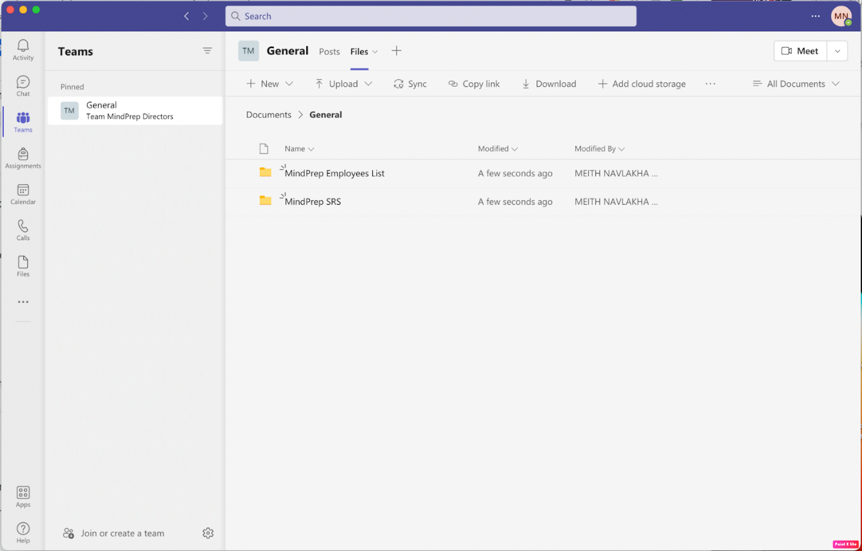

**4. MeetUI**

The meet UI enables the team owner to start a meet and add/invite other participants. Once the owner launches the meet, all the participants can on/off their camera, mute/unmute, , share screen, even access the chats as per the rights allocated to them.

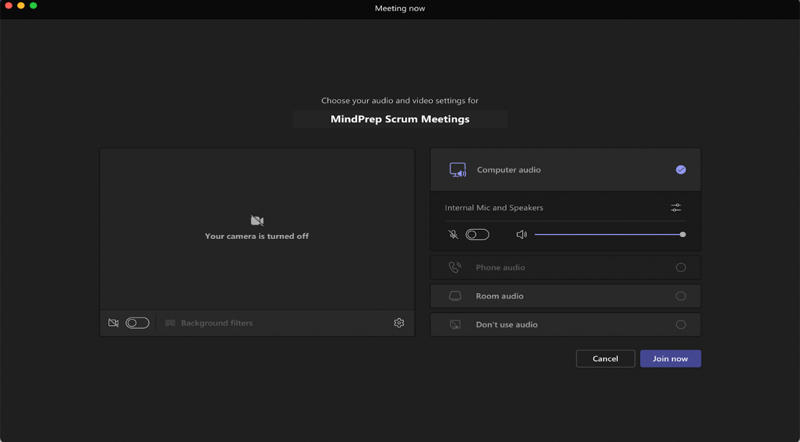

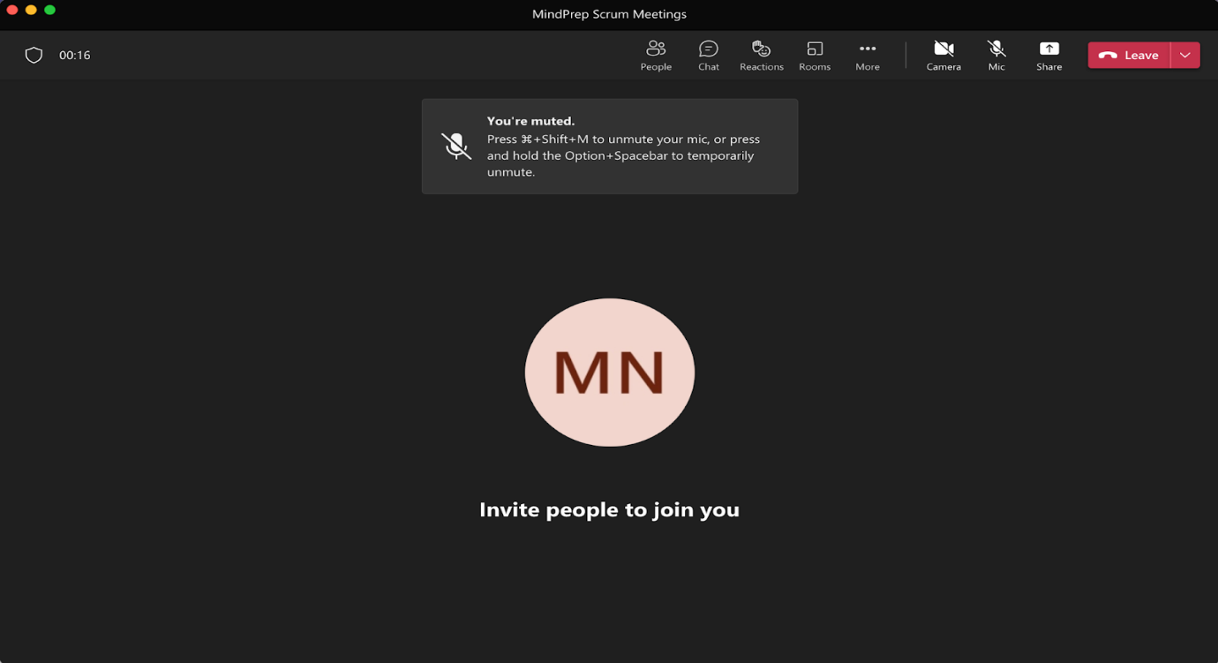

**5. FilesUI**

The files interface enables the user to download learning materials or any resources pertinent to the current project. The file resources can also be linked to OneDrive cloud storage. The user also has the facility to upload documents,presentations.

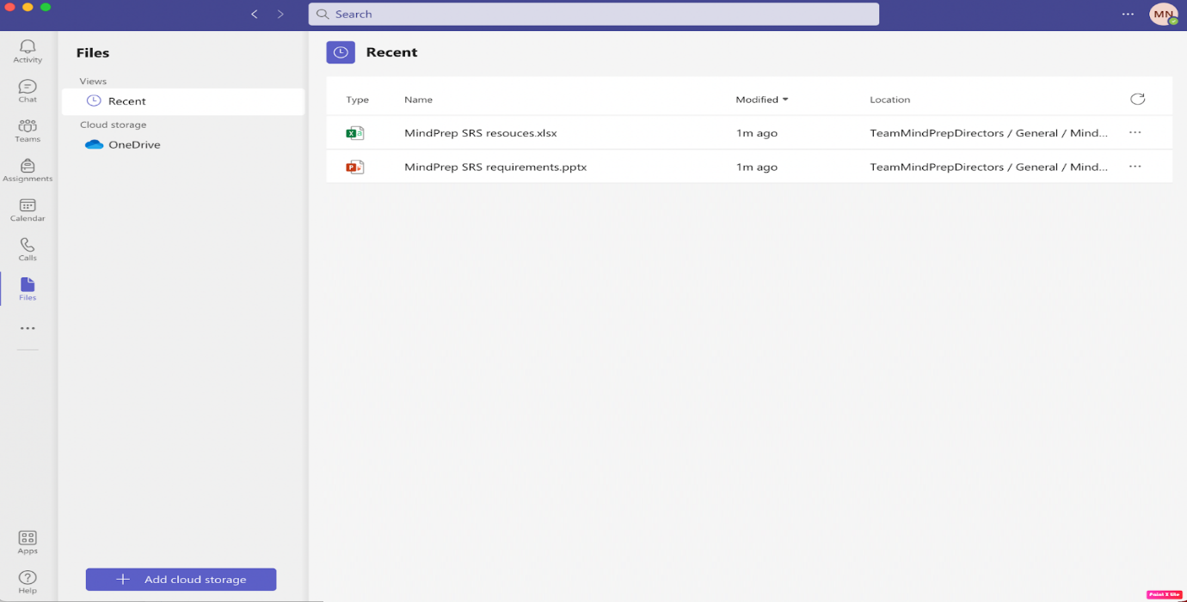

**6. AssigmentUI**

The assignment interface enables the team manager to set deadlines for projects and assignments. Once an assignment is created it notifies all team members. Also, the deadline and any instruction description or document can be added along. The members can upload their documents in the assignment and “turn in” for review.

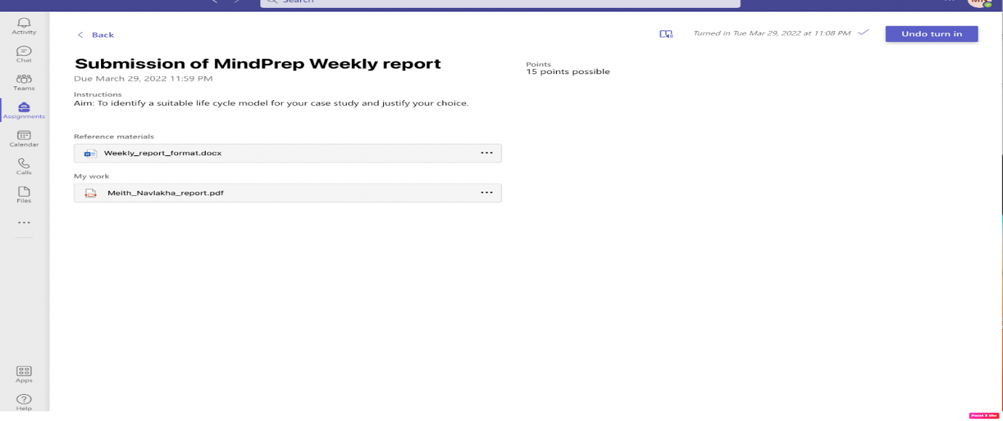

**7. Apps UI**

The apps interface enables the user to view and download additional applications as required by  the current project.  The UI incorporates filters based on categories, industries, recent and many more.

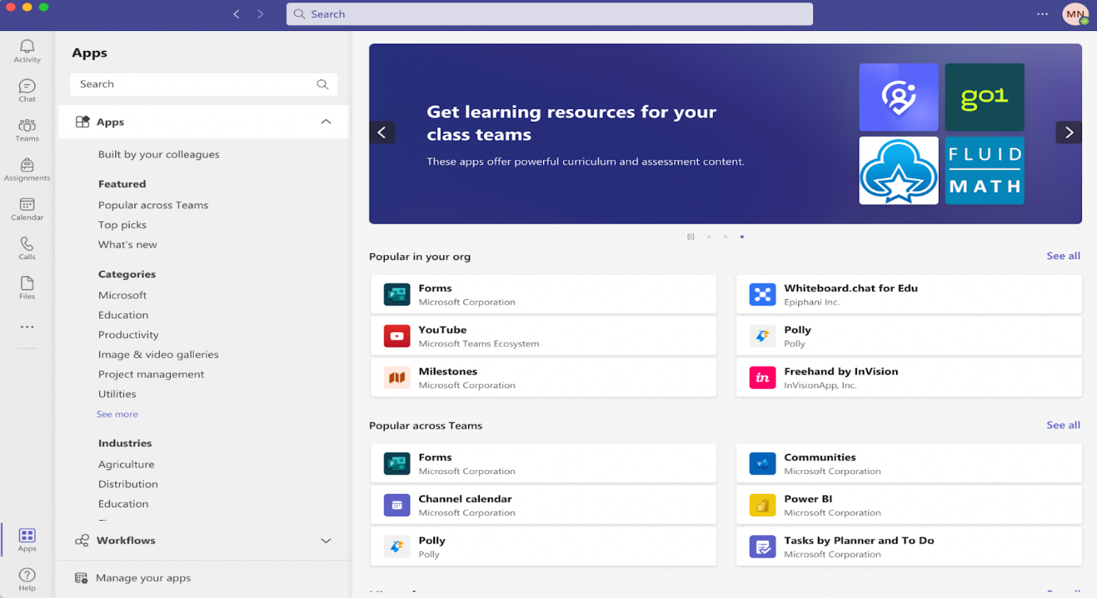

**8. ChatUI**

The chat interface enables the student to chat with other users of the MindPrep; personally or in a group.

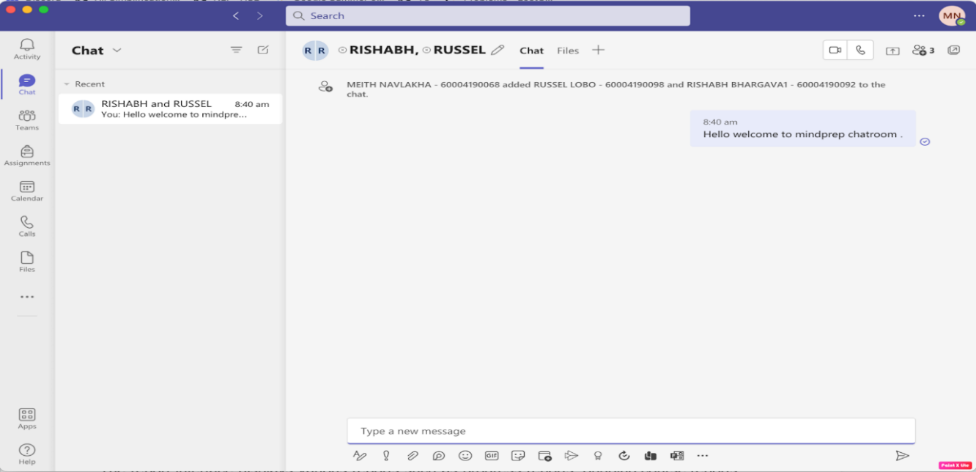

**9. ReportUI**

The report interface displays various reports such as progress reports, ongoing course reports, the engagement of the team members, attendance of the members in meetings. The analysis is also elucidated with the helps of charts for better data visualisation.

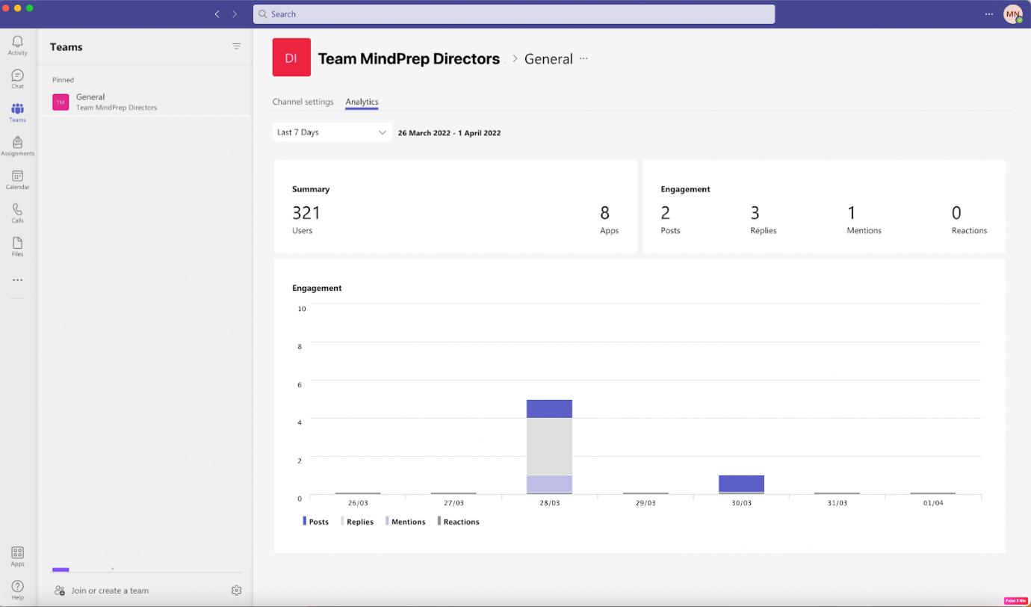

**10. Hardware Interfaces**

All server-side components must execute on server-class computers. All client-side components must execute on workstation-class and personal-class computers. The hardware interfaces for a personal-class computer are computer headset (combination of headphones and a microphone), webcam (optional) and minimum 56Kbps of bandwidth internet connection.

**11. Software Interfaces**

The software interface should follow the Model-View-Controller (MVC) model for rendering and modeling data objects. The interface must be able to connect to a database to store XML schema defined using XSD and data streams, to store documents based schema defined dynamically as per the model mentioned. Source and destination formats for data must include XML and may also include: Extensible Stylesheet Lanaguage Transformation (XSLT), JavaScript Object Notation (JSON), Comma Separated Value (CSV), and American Standard Code for Information Interchange (ASCII).

**12. Communications Interfaces**

The application should be able to communicate with the database using the specific authentication communication method while performing user authentication queries before accessing the database. For the web server we use WebSphere HTTP server. It maintains the server side database handling and the client implementation to view the html and Flash content. SMTP protocols are used for mailing the users for reminders, inviting to meet and other activities. FTP protocol is required for transferring, sharing and downloading of files and documents to and from the applications. Web Sockets are needed for real time chatting and video sharing features. IP network protocols and the software drivers that activate the peripheral devices.

**2. Functional Requirements**

This section provides a requirement overview of the system.

* **Teams and channels:** Users can create different teams and channels to create groups and organize classes with the required members only. Only the members of the team or channels can access the information and post announcements.
* **Chat features enabling conversations within channels and teams:** Users can chat with others privately using our chat feature within channels and teams.
* **Document storage in OneDrive:** Teachers can upload notes and students can upload their assignments. All these documents are stored in OneDrive so as to prevent data loss and provide security of data.
* **Online video meetings and screen sharing:** This feature allows for flexible online video meetings. Meetings can be scheduled beforehand. Our app also supports screen sharing.
* **Personalisation for users:** Our app provides three different themes Light, Dark and High contrast. Users can create reminders for meetings and view recorded meets at any time.
* **Inbuilt apps and additional plugins:** MindPrep provides inbuilt apps like MS Word, Excel and PowerPoint. Additional plugins include OneNote where the user can add notes and save it for future reference. This helps in enhancing the learning and teaching experience for the user.

**3. Behaviour Requirements**

**1. Use Case View**

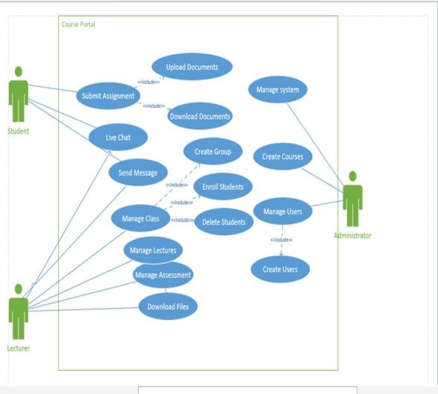

**4. Other Non-functional Requirements**

**1. Performance Requirements**

* **Response Time:** The loading time of each page/interface from the Product Module should be consistent. Each page/interface should load in less than 30 seconds. This requirement can be dependent on the user’s computer or the server itself.

* **Reliability:** The video quality should be clear and good.The audio could be heard well.The video and audio of lectures should be synchronised well.
* **Workload:** The module should be able to handle a large amount of users at any given time. The increased load should not influence the response time.
* **Availability:** 24 X 7 availability should be there so that the users can use it at any time as per their convenience. Incase of server breakdown a temporary backed up server must be ready.
* **Scalability:** Scalability is the increase in the system’s workload that the system should be able to process. The app should be able to handle traffic and not exceed the bandwidth limit.=

**2. Safety and Security Requirements**

* **User Authorization:** The application has different roles of users with different access and controlling rights. For example, the supervisor can see information of all the team members like personal information, attendance, work time entry and many more. This information must not be accessible to all the other team members. As a result user authorization needs to be regulated.
* **Loss of Data:** Incase of server crash or any other technical issue, resulting into loss of user’s data uploaded on the cloud must be taken care of as per the Reparation for Data Loss provision in the company’s privacy policy.
* **Expiring Inactive Sessions:** Inactive sessions should expire after a maximum time of 1 hour or when the user exits the app.
* **Multiple Fail Login Attempts:** Incase of successive fail login attempts within a short span must be flagged. The user must be warned about the failed attempts with a pop up message and a mail on the registered email if the user has 5 successive fail attempts within 1 min. More than 10 failed attempts in the next 3 minutes will result into soft banning of the account for the next 24 hours. This security feature is to make our application robust to brute force login attempts.

**3. Software Quality Attributes**

**4.3.1. Maintainability:** The module shall be designed with the view that bugs may need fixing, for future optimisations and for adding extra functionalities for other developers.

**4.3.2. Portability:** The module shall be designed such that it can be added to any system. It is also necessary for the module to be implemented in the same programming language to make it platform independent.

**4.3.3. Extendability:** The module shall be designed with the view that the ”optional” functional requirements will be implemented at a later date. Also the module shall be designed with a view that other tasks may be added to the module.

**5. Other Requirements**

NONE

**Appendix A – Data Dictionary**

|  |  |  |
| --- | --- | --- |
| Element Name | | Description |
| Camera | | A class to handle the camera’s functionality. |
| Attributes |  |  |
| Operations |  |  |
|  | TakePicture (): void | Takes a picture and adds it to the array of images used to identify a face. |
| UML Extensions | |  |

|  |  |  |
| --- | --- | --- |
| Element Name | | Description |
| Teams | | A class to handle the members of a team and keep the channel activities in check. |
| Attributes |  |  |
|  |  |  |
| Operations |  |  |
|  | createTeam (): void | Used by the organiser to create a team . |
|  | addMembers (): void | Used by the organiser to add the required members to the team. |
| UML Extensions | |  |

|  |  |  |
| --- | --- | --- |
| Element Name | | Description |
| Documents | | A data structure to store a document in oneDrive. |
| Attributes |  |  |
|  | documents | The document can have different formats eg:- .pdf .doc .xlsx etc. |
| Operations |  |  |
|  | uploadDoc (): void | Used by user to upload documents to OneDrive. |
| UML Extensions | |  |

**Appendix B - Group Log**

|  |  |  |  |  |
| --- | --- | --- | --- | --- |
| **SR. NO.** | **SUPERVISOR** | **TEAM  NAME** | **DATE** | **WEEKLY PROGRESS** |
|  |
| 1 | Pratham Bhoir | – | 16-02-2023 | Project discussion with the Client. |  |
| 2 | Pratham Bhoir,  Aayushman Gupta | Team Head | 23-02-2023 | Exploring issues related to the financial, technical, operational, and time management aspects of software development for the project and discussing it with the client |  |
| 3 | Aayushman Gupta | HR Team | 28-02-2023 | Designing the software architecture, Team Planning and allocation of resources and employees. |  |
| 4 | Pratham Bhoir | Development Team | 01-03-2023 | Updates on the app development and reallocation of resources as per requirements. |  |
| 5 | Aayushman Gupta | Testing Team | 04-03-2023 | Discuss about the bugs in phase 1 testing of the application |  |
| 6 | Aayushman Gupta | HR Team, Dev Team, Testing Team | 07-03-2023 | Short meeting to discuss about the bugs and changes. |  |
| 7 | Pratham Bhoir | Development Team | 14-03-2023 | Resolve the bugs and deploy for beta testing. |  |
| 8 | Aayushman Gupta | Testing Team | 21-03-2023 | Discuss about the bugs of the beta phase. |  |
| 9 | Aayushman Gupta | HR Team | 28-03-2023 | Short meeting to discuss the workflow and various issues faced by the employees |  |
| 10 | Pratham Bhoir,  Aayushman Gupta | Team Head | 07-04-2023 | Present the MindPrep application to the client along with the SRS. |  |

**SAPID:** 60004200082, 60004200066

**Names:** Pratham Bhoir, Aayushman Gupta

**Batch:** A2

**Experiment No. 3**

**Aim:** To identify scenarios and develop UML Use-Case and Class Diagrams for the project. **Title**: MIND PREP

**Theory:**

**1.** **Use-case diagrams:**

In UML, use-case diagrams model the behavior of a system and help to capture the requirements of the system.

Use-case diagrams describe the high-level functions and scope of a system. These diagrams also identify the interactions between the system and its actors. The use cases and actors in usecase diagrams describe what the system does and how the actors use it, but not how the system operates internally. Use-case diagrams illustrate and define the context and requirements of either an entire system or the important parts of the system.

•        Use cases: A use case describes a function that a system performs to achieve the user’s goal. A use case must yield an observable result that is of value to the user of the system.

•        Actors: An actor represents a role of a user that interacts with the system that you are modeling. The user can be a human user, an organization, a machine, or another external system.

•        Subsystems: In UML models, subsystems are a type of stereotyped component that represent independent, behavioral units in a system. Subsystems are used in class, component, and use-case diagrams to represent large-scale components in the system that you are modeling.

•        Relationships in use-case diagrams: In UML, a relationship is a connection between model elements. A UML relationship is a type of model element that adds semantics to a model by defining the structure and behavior between the model elements.

**2.** **Class diagrams:**

Class diagram is a static diagram. It represents the static view of an application. Class diagram is not only used for visualizing, describing, and documenting different aspects of a system but also for constructing executable code of the software application.

Class diagram describes the attributes and operations of a class and the constraints imposed on the system. The class diagrams are widely used in the modeling of object-oriented systems because they are the only UML diagrams, which can be mapped directly with object-oriented languages. Class diagram shows a collection of classes, interfaces, associations, collaborations, and constraints. It is also known as a structural diagram.

**Use-case diagram for MINDPREP:**

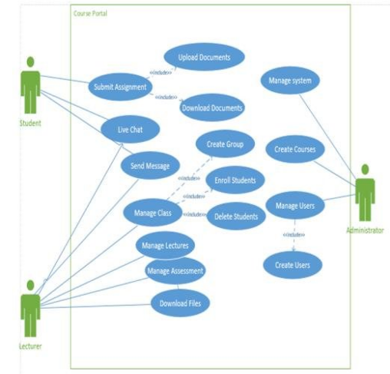

**Class diagram for MINDPREP:**

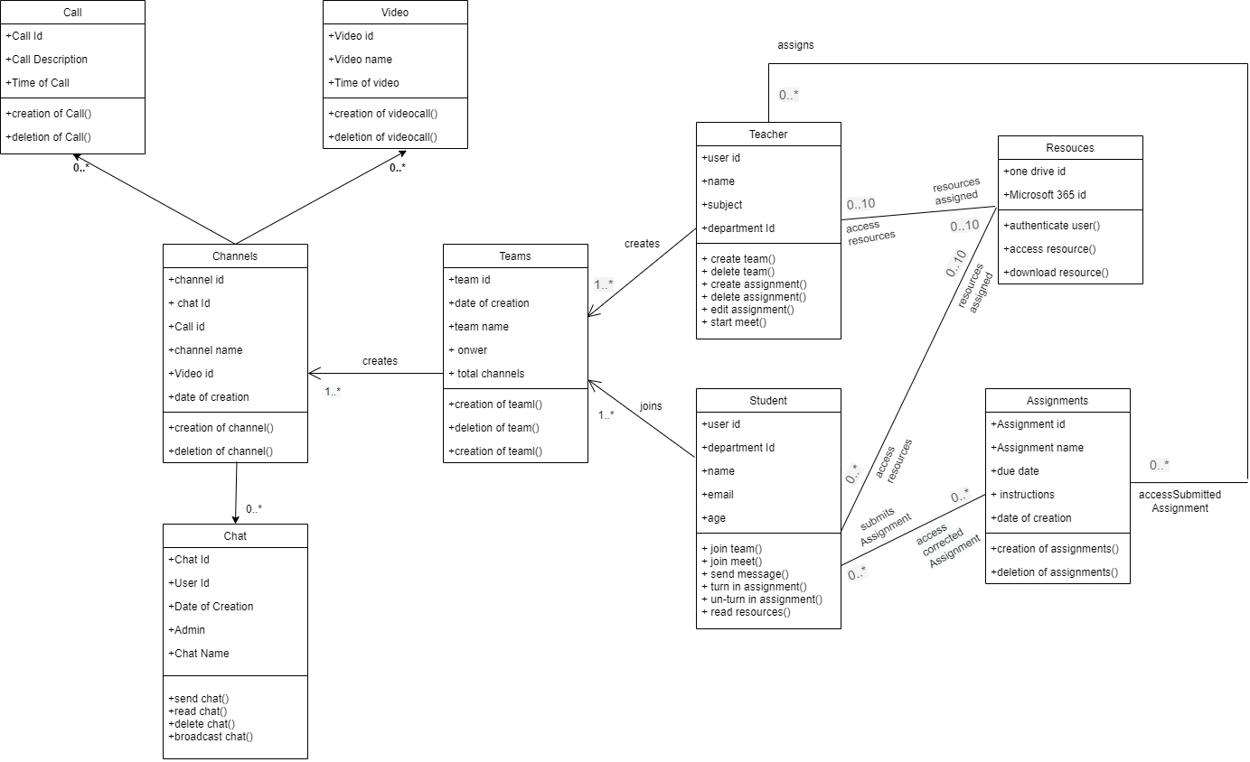

**Conclusion:**

In this experiment we implemented and understood the use-case diagram as well as the class diagram for MindPrep system. The actors identified are teachers,students,resources. The UML use-case diagram summarizes the details of our system’s users and their interactions with the system. The class diagram depict the structure of our software and describe what must be present in the system being modelled.

**SAPID:** 60004200082, 60004200066

**Names:** Pratham Bhoir, Aayushman Gupta

**Batch:** A2

**Experiment No. 4**

**Aim:** Develop Activity diagram and DFD (up to 2 levels) for the project.

**Theory:**

**Activity Diagram**:

A UML activity diagram depicts the dynamic behavior of a system or part of a system through the flow of control between actions that the system performs. It is similar to a flowchart except that an activity diagram can show concurrent flows. The main component of an activity diagram is an action node, represented by a rounded rectangle, which corresponds to a task performed by the software system. Arrows from one action node to another indicate the flow of control. That is, an arrow between two action nodes means that after the first action is complete the second action begins. A solid black dot forms the initial node that indicates the starting point of the activity. A black dot surrounded by a black circle is the final node indicating the end of the activity. A fork represents the separation of activities into two or more concurrent activities. It is drawn as a horizontal black bar with one arrow pointing to it and two or more arrows pointing out from it. Each outgoing arrow represents a flow of control that can be executed concurrently with the flows corresponding to the other outgoing arrows. These concurrent activities can be performed on a computer using different threads or even using different computers.

**Data Flow Diagrams:**

The data flow diagram enables you to develop models of the information domain and functional domain. As the DFD is refined into greater levels of detail, you perform an implicit functional decomposition of the system. At the same time, the DFD refinement results in a corresponding refinement of data as it moves through the processes that embody the application.

Guidelines for drawing a data flow diagram:

(1) the level 0 data flow diagram should depict the software/system as a single bubble;

(2) primary input and output should be carefully noted;

(3) refinement should begin by isolating candidate processes, data objects, and data stores to be represented at the next level;

(4) all arrows and bubbles should be labeled with meaningful names;

(5) information flow continuity must be maintained from level to level,2 and

(6) one bubble at a time should be refined.

**Swimlane diagram for Learning Management system:**

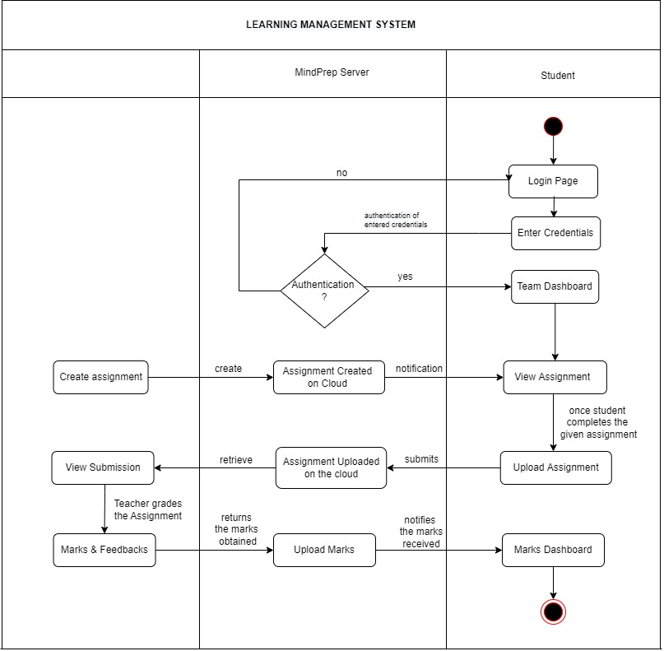

To indicate how the actions are divided among the participants, one can decorate the activity diagram with swim lanes. Swim lanes are formed by dividing the diagram into strips or “lanes,” each of which corresponds to one of the participants. All actions in one lane are done by the corresponding participant.

Data Flow Diagrams Level 0 and Level 1 for MindPrep application.

**DFD LEVEL 0:**

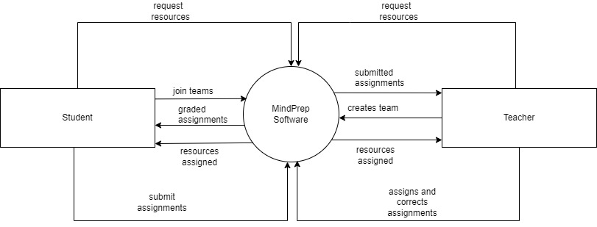

**DFD LEVEL 1:**

**DFD LEVEL 2:**

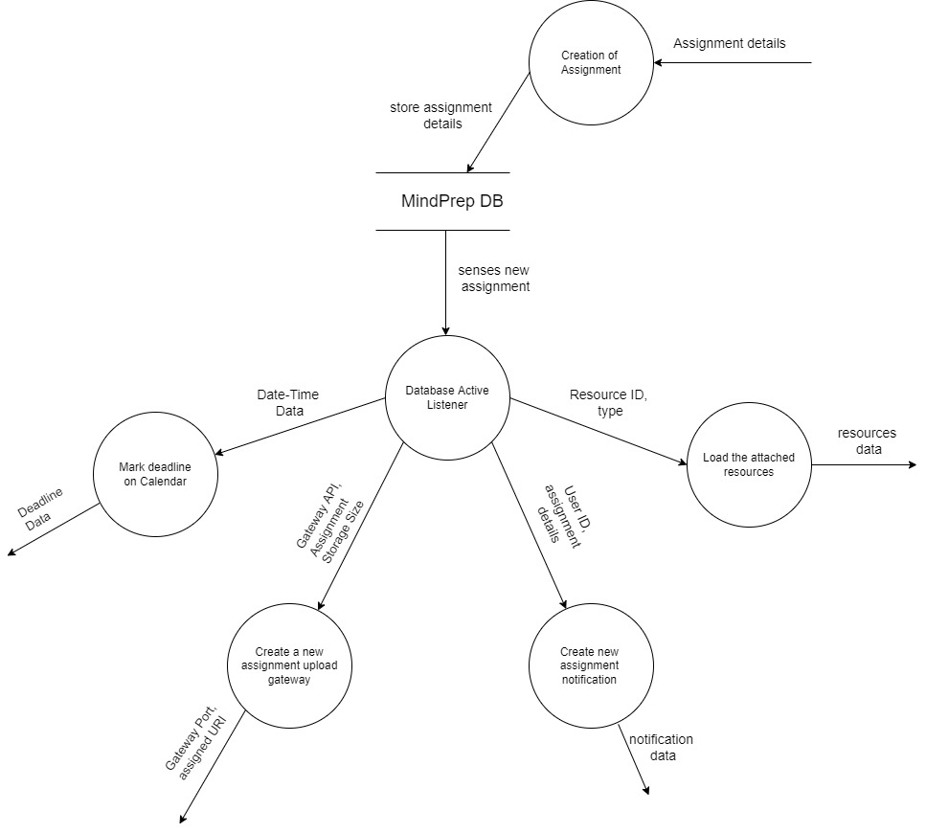

**Conclusion:**

Thus, we are able to draw Activity and Swim lane diagram for our case study. We are also able to depict the flow of data through various processes through different level DFDs.

**SAPID:** 60004200082, 60004200066

**Names:** Pratham Bhoir, Aayushman Gupta

**Batch:** A2

**Experiment No. 5**

**Aim:** Estimate effort and cost required using FP/COCOMO for the project. Create WBS and Gantt Chart for the same. Use PM Tool to depict a project plan.

**Theory:**

**Work Breakdown Structure:**

 Work Breakdown Statement

A work breakdown statement (WBS) is a categorized list of tasks with an estimate of resources required to complete the task. An example WBS appears below.

|  |  |  |  |  |  |
| --- | --- | --- | --- | --- | --- |
| WBS  # | Task  Description | Est  Person  -Hrs | Who | Resources | M&S |
| 5 | Profile motor power |  |  |  |  |
| 5.1 | Design test stand | 20 | SE, JM | Pro/E |  |
| 5.2 | Build test stand | 15 | SE, JM | Frame & brake parts | $35 |
| 5.3 | Test 3 motors | 3 | SE, JM | Stroboscope | $75 |
| 5.4 | Plot torque vs. speed | 2 | JM | Excel |  |

(M&S = Materials & Supplies)

Gantt Chart Basics

Gantt charts are a project planning tool that can be used to represent the timing of tasks required to complete a project. Because Gantt charts are simple to understand and easy to construct, they are used by most project managers for all but the most complex projects.

In a Gantt chart, each task takes up one row. Dates run along the top in increments of days, weeks or months, depending on the total length of the project. The expected time for each task is represented by a horizontal bar whose left end marks the expected beginning of the task and whose right end marks the expected completion date. Tasks may run sequentially, in parallel or overlapping.

As the project progresses, the chart is updated by filling in the bars to a length proportional to the fraction of work that has been accomplished on the task. This way, one can get a quick reading of project progress by drawing a vertical line through the chart at the current date. Completed tasks lie to the left of the line and are completely filled in. Current tasks cross the line and are behind schedule if their filled-in section is to the left of the line and ahead of schedule if the filled-in section stops to the right of the line. Future tasks lie completely to the right of the line.

In constructing a Gantt chart, keep the tasks to a manageable number (no more than 15 or 20) so that the chart fits on a single page. More complex projects may require subordinate charts which detail the timing of all the subtasks which make up one of the main tasks. For team projects, it often helps to have an additional column containing numbers or initials which identify who on the team is responsible for the task.

Often the project has important events which you would like to appear on the project timeline, but which are not tasks. For example, you may wish to highlight when a prototype is complete or the date of a design review. You enter these on a Gantt chart as "milestone" events and mark them with a special symbol, often an upside-down triangle.

**Practical:**

**1). For Estimation:**

**FP  ESTIMATION :**

**External inputs:** Login credentials , upload assignment, upload resources

**External Inquiry:** Registration details, Resources  assigned, Lecture history

**Internal Logical Files:** Team details, Channel details, Assignments Details

**External Outputs:** Assignment Grades ,

**External interface files:**  NONE

|  |  |  |  |  |  |
| --- | --- | --- | --- | --- | --- |
| **Information Domain Value** | **Count** | **Simple** | **Average** | **Complex** | **Total** |
| **External inputs** | 3 | 3 | 4 | 6 | 3*6=18 |
| **External enquiry** | 3 | 4 | 5 | 7 | 3*7=21 |
| **Internal Logical Files** | 3 | 3 | 4 | 6 | 3*6=18 |
| **External Outputs** | 1 | 7 | 10 | 15 | 1*15=15 |
| **External interface files** | 0 | 5 | 7 | 10 | 0*10=0 |
| Total | | | | | 72 |

**Total-Count =** 72

**Value Adjustment Factors:**

**Does the system require reliable backup and recovery?**

**5** →  Student records (grades, assignments) are present which are required by the institutions and cannot be lost.

**Are specialized data communications required to transfer information to or from the application?**

**3** - The application requires a medium level of security for transfer of information as it will mostly be student assignments and class attendance.

**Are there distributed processing functions?**

**1** - The application has a single central datastore and all processing functions are closely related.

**Is performance critical?**

**4** - The application deals with daily live video lectures and constant assignment updates. If the performance needs to be optimal in order to ensure smooth flow of lectures and assignment submission.

**Will the system run in an existing, heavily utilized operational environment?**

**0** - The application is a new product with no existing operational environments.

**Does the system require online data entry?**

**3** - Practically all functionalities require some form of data entry but most of them are simple and straightforward.

**Does the online data entry require the input transaction to be built over multiple screens or operations?**

**3** - A few functionalities in the application requires data entry over multiple screens.

**Are the ILFs updated online?**

**4** - The application has a single datastore that is updated each time one of the functionalities is accessed.

**Are the inputs, outputs, files, or inquiries complex?**

**2** - All the inputs, outputs, files and inquiries are simple.

**Is the internal processing complex?**

**3** - Most of the internal processing is simple except for the live videos which require uninterrupted streaming.

**Is the code designed to be reusable?**

**3** - The code can be reused over multiple functionalities with minor modifications.

**Are conversion and installation included in the design?**

**5** - The application will already have all third party and additional components installed.

**Is the system designed for multiple installations in different organizations?**

**4** - The application can have multiple installations in different organizations with minor modifications that may be necessary.

**Is the application designed to facilitate change and ease of use by the user?**

**4** - The application has been designed while keeping ease of use for the customer in mind.

Σ (Fi ) = 44

The estimated number of FP is derived:

FP estimated = count-total x [0.65 + 0.01 x Σ (Fi )]

= 72* [0.65 + 0.01 x 44]

=  78.48

Therefore, FP estimated is **78.48** pm

**For WBS and Gantt Chart**

**WBS:**

1. Project Management

1.1.  Project Setup / Initiation

1.2.  Project Plan Documentation

1.3.  Project Schedule Development & Management

1.4.  Risk Management

2. Analysis / Requirements

2.1.  Use Case Meetings & Documentation

2.2.  Requirements Meetings & Documentation

3. Design

3.1.     Database Design Meetings & Documentation

3.2.  Application Design Meetings & Documentation

3.3.  System Architecture Design Meetings & Documentation

3.4.  System Integration Design Meetings & Documentation

4. Application Development

4.1.  Programming

4.1.1.     Programming for Teams Module

4.1.2.     Programming for Channels Module

4.1.3.     Programming for  Integrating Calls,Videos,Chats

4.1.4.     Programming for Resource Management Module

4.1.5.     Programming for Assignment tracking and Management Module

4.1.6.     Programming for Various resource plugins Management Module

4.1.7.     Database Development

4.1.8.     Programming for Application Integration

4.2.  Code Reviews

4.3.  Application Testing

4.3.1.     Test Documentation

4.3.2.     Unit Testing

4.3.3.     Integration Testing

4.3.4.     Acceptance Testing

4.3.5.     System Testing

5. Deployment

5.1.  Release Planning & Management

5.2.  Issue / Bug Management

5.3.  Server Management

5.4.  Source Code Management

5.5.  Database Management

5.6.  All forms of Documentation

6. Operations & Maintenance

6.1.  System Administration

6.2.  System Tuning

6.3.  User Support & Help Desk

**GANTT TIMELINE CHART :**

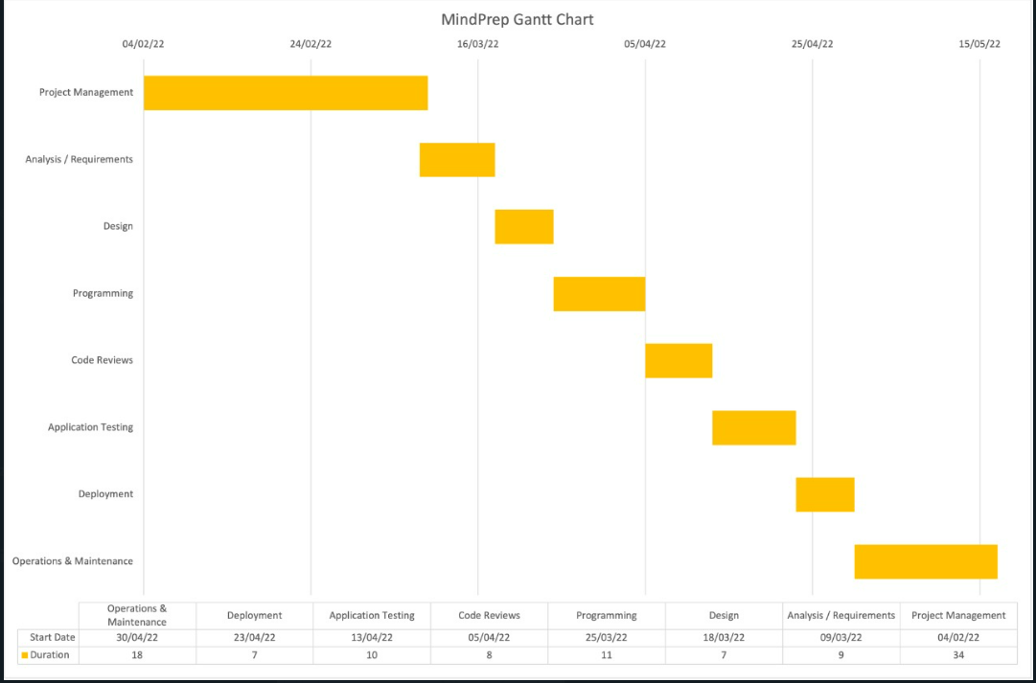

**Conclusion:**

 Thus, we are able to estimate effort required for our project and also create WBS and Gantt Chart.

**SAPID:** 60004200082, 60004200066

**Names:** Pratham Bhoir, Aayushman Gupta

**Batch:** A2

**Experiment No. 6**

**Aim:** Develop Sequence and Collaboration diagram for the project.

**Theory:**

**Sequence Diagram**:

A sequence diagram is used to show the dynamic communications between objects during execution of a task. It shows the temporal order in which messages are sent between the objects to accomplish that task. One might use a sequence diagram to show the interactions in one use case or in one scenario of a software system.

A sequence diagram shows method calls using horizontal arrows from the caller to the callee, labeled with the method name and optionally including its parameters, their types, and the return type.

The figure shows a sequence diagram for a drawing program. The diagram shows the steps involved in highlighting a figure in a drawing when it has been clicked. Each box in the row at the top of the diagram usually corresponds to an object, although it is possible to have the boxes model other things, such as classes. If the box represents an object (as is the case in all our examples), then inside the box you can optionally state the type of the object preceded by the colon. You can also precede the colon and type by a name for the object, as shown in the third box in Figure. Below each box there is a dashed line called the lifeline of the object. The vertical axis in the sequence diagram corresponds to time, with time increasing as you move downward. The diagram in Figure is very straightforward and contains no conditionals or loops. If logical control structures are required, it is probably best to draw a separate sequence diagram for each case. That is, if the message flow can take two different paths depending on a condition, then draw two separate sequence diagrams, one for each possibility

|  |  |
| --- | --- |
|  |  |

**Collaboration (communication) Diagrams:**

A collaboration diagram, illustrated in Figure below, displays the same actions shown in the sequence diagram in Figure.

In a collaboration diagram the interacting objects are represented by rectangles. Associations between objects are represented by lines connecting the rectangles. There is typically an incoming arrow to one object in the diagram that starts the sequence of message passing. That arrow is labeled with a number and a message name. If the incoming message is labeled with the number 1 and if it causes the receiving object to invoke other messages on other objects, then those messages are represented by arrows from the sender to the receiver along an association line and are given numbers 1.1, 1.2, and so forth, in the order they are called. If those messages in turn invoke other messages, another decimal point and number are added to the number labeling these messages, to indicate further nesting of the message passing. In Figure, you see that the mouseClicked message invokes the methods getFigureAt() and then highlight(). The highlight() message invokes three other messages: setColor(), drawRect(), and drawstring(). The numbering in each label shows the nesting as well as the sequential nature of each message.

**Practical:**

**For Sequence diagram**

We have used the Login Functionality

**For Collaboration diagram**

**Conclusion:**

Thus, we are able to draw Sequence and Collaboration diagram for a functionality of our case study.

**SAPID:** 60004200082, 60004200066

**Names:** Pratham Bhoir, Aayushman Gupta

**Batch:** A2

**Experiment No. 7**

**Aim:** Design test scenarios and test cases for your SRS.

**Performance:**

1. **Create test scenario and test cases for your case study**
2. **Use the following template for the Test Scenario**

|  |  |  |  |  |
| --- | --- | --- | --- | --- |
| Test scenario ID | Requirement- reference document index | Test scenario description | Importance | No. of test cases |
| TS_MI | Section 3, Page 3 | validate if the user is able to enter the MindPrep system with a successful User account | High | 2 |
| TS_PI | 3.1.2 | Validate if the user can upload an assignment from the site of the format (jpg, doc, pdf ) | Medium | 3 |
| TS_SI | 4.1 | validate if the system is compatible with Internet Explorer 4, 5 and 5.5, and with Firefox 4-6, as well as Google Chrome 4.0 and later.Also validate if it is applicable with Android 7.0. | Medium | 4 |

**Column #1: Test scenario ID**  
Every entity in our testing process has to be uniquely identifiable. So, every test scenario has to be assigned an ID. The rules to follow while assigning this ID have to be defined. For the sake of this article we are going to follow the naming convention as: TS(prefix that stands for Test Scenario) followed by ‘_’ , module name MI(my Info module of the Orange HRM project) followed by ‘_’ and then the sub section (eg: MIM for My info module, P for photograph and so on)followed by a serial number. An example would be: “TS_MI_MIM_01”.

**Column #2: Requirement**  
It helps that when we create a test scenario we should be able to map it back to the section of the SRS document where we picked it from. If the requirements have IDs we could use that. If not section numbers or even page numbers of the SRS document from where we identified a testable requirement will do.

**Column #3: Test scenario description**  
A one liner specifying ‘what to test’. We would also refer to it as test objective.

**Column #4: Importance**  
This is to give an idea about how important certain functionality is for the AUT. Values like high, medium and low can be assigned to this field. You could also choose a point system, like 1-5, 5 being most important, 1 being less important. Whatever the value this field can take, it has to be pre-decided.

**Column #5: No. of Test cases**  
A rough estimate on how many individual test cases we might end up writing that one test scenario. **For example**: To test the login- we include these situations: Correct username and password. Correct username and wrong password. Correct password and wrong username. So, validating the login functionality will result in 3 test cases.

1. **Use the following template for the Test Cases**

|  |  |  |  |  |  |  |
| --- | --- | --- | --- | --- | --- | --- |
| **Test case ID** | **Test Objective** | **Precondition** | **Steps:** | **Test data** | **Expected result** | **Post-condition** |
| **TC_MI_01** | **Successful Employee login to OrangeHRM portal** | **1. A valid ESS-User account to login to be available 2. MindPrep system is launched on a compatible browser,android application** | **1. In the login Panel, enter the username** | **"A valid username" Enter the actual data : password:-- MindPrep0014** | **The user is logged in successfully.** | **For first time users personal information is displayed.** |
|  |  |  | **2. Enter the Password for the ESS-User account in the password field** | **"A valid Password"-- Xyzesw@13#** |  |  |
|  |  |  | **3. Click "Login" button** |  |  |  |
| **TC_MI_02** | **Error message on unsuccessful Employee login to MindPrep system** | **1. A User name to login to be available 2. MindPrep system is launched on a compatible browser,android application** | **1. In the login Panel, enter the username** | **"A valid username"** | **An Error message is displayed and the user is not logged in to the Orange HRM portal. "<Exact Error Message>" .** |  |
|  |  |  | **2. Enter the Password for the User account in the password field** | **"A invalid Password"** |  |  |
|  |  |  | **3. Click "Login" button** |  |  |  |
| **TC_PI_01** | **Check the upload of a format pdf file as Assignment** | **1. MindPrep site/application is launched on a compatible device and a User account holder is logged in to the system 2. A assignment to upload that is pdf in format in size is available on the local machine a location** | **Click on the assignment button displayed at the top left corner of the page** |  | **The "assignment screen" will be displayed** | **This page will contain options to select and upload assignments** |
|  |  |  | **Click on "Choose a file" button** |  | **You will be able to browse your local machine for pdf** |  |
|  |  |  | **Choose a pdf file of type "assignment"** | **Name of the assignment Location-path on the machine** | **The file name is selected in the "Choose a file" box** |  |
|  |  |  | **Click on upload** |  | **The file gets uploaded and the older image is replaced** | **It takes 2-5 depending on the size of the image for this change to complete and the page to refresh with the assignment.** |
| **TC_PI_02** | **Check the upload of format image as assigment** | **1. MindPrep site/application is launched on a compatible device and a User account holder is logged in to the system 2. A assignment to upload that is pdf in format in size is available on the local machine a location** | **Click on the assignment button displayed at the top left corner of the page** |  | **The "assignment screen" will be displayed** | **This page will contain options to select and upload pictures.** |
|  |  |  | **Click on "Choose a file" button** |  | **You will be able to browse your local machine for images** |  |
|  |  |  | **Choose a image file of type "assignment"** | **Name of the assignment Location-path on the machine** | **The file name is selected in the "Choose a file" box** |  |
|  |  |  | **Click on upload** |  | **The file gets uploaded and the older image is replaced** | **It takes 2-5 depending on the size of the image for this change to complete and the page to refresh with the new image.** |
| **TC_PI_03** | **Check the upload of format Document as assigment** | **1. MindPrep site/application is launched on a compatible device and a User account holder is logged in to the system 2. A assignment to upload that is pdf in format in size is available on the local machine a location** | **Click on the assignment button displayed at the top left corner of the page** |  | **The "assignment screen" will be displayed** | **This page will contain options to select and upload pictures.** |
|  |  |  | **Click on "Choose a file" button** |  | **You will be able to browse your local machine for images** |  |
|  |  |  | **Choose a document file of type "assignment"** | **Name of the assignment Location-path on the machine** | **The file name is selected in the "Choose a file" box** |  |
|  |  |  | **Click on upload** |  | **The file gets uploaded and the older document is replaced** | **It takes 2-5 depending on the size of the document for this change to complete and the page to refresh with the new image.** |
| **TC_SI_01** | **Check the Compatibility of MindPrep with browser Internet explorer** | **1. Installation of browser internet explorer on the device** | **MindPrep is loaded on the browser** |  | **MindPrep system will be loaded succesfully** | **MindPrep system will be displayed on screen** |
|  |  |  | **Elements(buttons.forms,menus) are visible** |  |  |  |
|  |  |  | **Elements are clickable** |  | **Elements can be used by clicking on it** |  |
|  |  |  | **Content of pages are visible** |  | **Content,text are readable** |  |
|  |  |  | **All the plugins supported** | **The name of the Plugin to be used** | **Plugins can be used on the browser** |  |
| **TC_SI_02** | **Check the Compatibility of MindPrep with browser Google** | **1. Installation of browser Google Chrome on the device** | **MindPrep is loaded on the browser** |  | **MindPrep system will be loaded succesfully** | **MindPrep system will be displayed on screen** |
|  |  |  | **Elements(buttons.forms,menus) are visible** |  |  |  |
|  |  |  | **Elements are clickable** |  | **Elements can be used by clicking on it** |  |
|  |  |  | **Content of pages are visible** |  | **Content,text are readable** |  |
|  |  |  | **All the plugins supported** | **The name of the Plugin to be used** | **Plugins can be used on the browser** |  |
| **TC_SI_03** | **Check the Compatibility of MindPrep with browser Firefox** | **1. Installation of browser Firefox on the device** | **MindPrep is loaded on the browser** |  | **MindPrep system will be loaded succesfully** | **MindPrep system will be displayed on screen** |
|  |  |  | **Elements(buttons.forms,menus) are visible** |  |  |  |
|  |  |  | **Elements are clickable** |  | **Elements can be used by clicking on it** |  |
|  |  |  | **Content of pages are visible** |  | **Content,text are readable** |  |
|  |  |  | **All the plugins supported** | **The name of the Plugin to be used** | **Plugins can be used on the browser** |  |
| **TC_SI_04** | **Check the Compatibility of MindPrep with Android** | **1. Installation of Android on the device** | **MindPrep is loaded on the browser** |  | **MindPrep system will be loaded succesfully** | **MindPrep system will be displayed on screen** |
|  |  |  | **Elements(buttons.forms,menus) are visible** |  |  |  |
|  |  |  | **Elements are clickable** |  | **Elements can be used by clicking on it** |  |
|  |  |  | **Content of pages are visible** |  | **Content,text are readable** |  |
|  |  |  | **All the plugins supported** | **The name of the Plugin to be used** | **Plugins can be used on the browser** |  |

**Test case ID**: Unique ID for each test case. Follow some convention to indicate types of test. E.g. ‘TC_UI_1′ indicating ‘user interface test case #1′.

**Test Objective**: Describe what the test case is actually going to test.

**Pre-condition**: Any prerequisite that must be fulfilled before execution of this test case. List all pre-conditions in order to successfully execute this test case.

**Dependencies**: Mention any dependencies on other test cases or test requirement.

**Test Steps**: List all test execution steps in detail. Write test steps in the order in which these should be executed. Make sure to provide as much details as you can. Tip – to efficiently manage test case with lesser number of fields use this field to describe test conditions, test data and user roles for running test.

**Test Data**: Use of test data as an input for this test case. You can provide different data sets with exact values to be used as an input.

**Expected Result**:  What should be the system output after test execution? Describe the expected result in detail including message/error that should be displayed on screen.

**Post-condition**: What should be the state of the system after executing this test case?

**Actual result**: Actual test result should be filled after test execution. Describe system behavior after test execution.

**Conclusion:**

Thus, we are able to create test scenarios and test cases for our case study.

**SAPID:** 60004200082, 60004200066

**Names:** Pratham Bhoir, Aayushman Gupta

**Batch:** A2

**Experiment No. 9**

**Aim:** To create a RMMM plan: Create risk assessment template for a case study

**Performance:**

1. **Identify Risks** 
   1. Refer to the Risk Identification Checklist to be identify the risk
      1. Product Size Risks
      2. Business Impact Risks
      3. Customer Related Risks
      4. Process Risks
      5. Technical Issues
      6. Technology Risks
      7. Development Environment Risks
      8. Staff Size and Experience Risks
2. **Prepare Risk Table by identifying potential risks and categorizing their impacts as follows**

Impact Values:

1 – Catastrophic

2 – Critical

3 – Marginal

4 – Negligible

Risk Table

|  |  |  |  |
| --- | --- | --- | --- |
| **Risks** | **Category** | **Probability** | **Impact** |
| Computer Crash | TI | 70% | 1 |
| Late Delivery | BU | 30% | 1 |
| Technology will not Meet Expectations | TE | 25% | 1 |
| End Users Resist System | BU | 20% | 1 |
| Changes in Requirements | PS | 20% | 2 |
| Lack of Development Experience | TI | 20% | 2 |
| Lack of Database Stability | TI | 40% | 2 |
| Poor Quality Documentation | BU | 35% | 2 |
| Deviation from Software Engineering Standards | PI | 10% | 3 |
| Poor Comments in Code | TI | 20% | 4 |
| Loss of Potential Market | BU | 50% | 4 |
| IT system breakdown | TI | 30% | 3 |

1. **Create a Risk Mitigation, Monitoring and Management plan for the Risks identified in the Risk Table**

RMMM plan – Loss of Potential Market

|  |  |  |  |
| --- | --- | --- | --- |
| **Risk Information Sheet** | | | |
| **RISK ID:** P01-4-12 | **DATE:** 02/05/23 | **PROBABILITY:** 50% | **IMPACT:** high |
| **Description:**  With the covid cases curbing and life going back to normalcy, the demand for online learning management system is decreasing, as it was during the last few years. | | | |
| **Refinement/Context:**  Sub-Condition 1: Need for video conferencing and daily calendar scheduling is reducing as the learning is moving back to offline modes.  Sub-Condition 2: Quality of the application is not maintained upto the necessary standards.  Sub-Condition 3: Strict competition with other available platforms at competitive pricing. | | | |
| **Mitigation / Monitoring:**   1. Reduce expenditure on video conferencing and daily lecture scheduling features like lectures and calendar and focus on more assignment management features. 2. Unit testing must be done while to ensure the quality is maintained at each step. 3. Call the subject matter expert to the discuss about the risk and seek his advice. | | | |
| **Management / Contingency Plan / Trigger:**   1. The Risk Exposure(RE) calculated is around Rs.4,00,000 due to outsourcing certain components from a third party. | | | |
| **Current Status:**  20/05/22: Mitigation Steps Intitiated | | | |
| **Originator:** Pratham Bhoir | | **Assigned B:** Aayushman Gupta | |

**Conclusion:**

In this experiment, I have designed a RMMM plan for loss of potential market of our E-Learning application. With everything going back to normalcy, the need for video conferencing and online lecture scheduling is decreasing. Also, strict competition from the other platforms is other major concern. The Risk Exposure have been calculated and the Mitigation plan has been implemented.

**SAPID:** 60004200082, 60004200066

**Names:** Pratham Bhoir, Aayushman Gupta

**Batch:** A2

**Experiment No. 10**

**Aim:** Study of Configuration Management using GitHub

**Theory:**

Git is a distributed revision control and source code management system with an emphasis on speed. Git was initially designed and developed by Linus Torvalds for Linux kernel development. Git is a free software distributed under the terms of the GNU General Public License version 2.

Git Life Cycle

General workflow is as follows −

1. Clone the Git repository as a working copy.
2. Modify the working copy by adding/editing files.
3. If necessary, update the working copy by taking other developer's changes.
4. Review the changes before commit.
5. Commit changes. If everything is fine, then push the changes to the repository.
6. After committing, if something is wrong, then correct the last commit and push the changes to the repository.

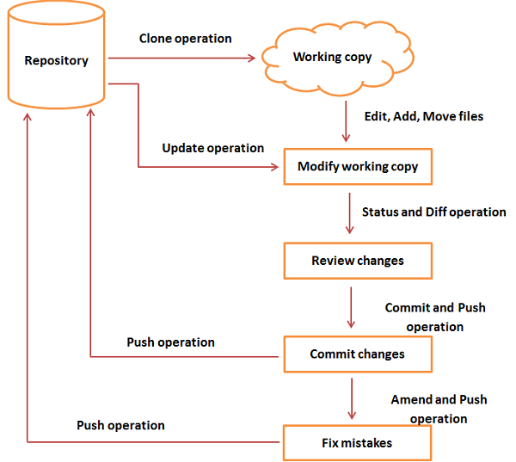

Git Life Cycle

1. Creating Git Repository

Initialize a new repository by using **init** command followed by **--bare** option. It initializes the repository without a working directory. By convention, the bare repository must be named as **.git**.

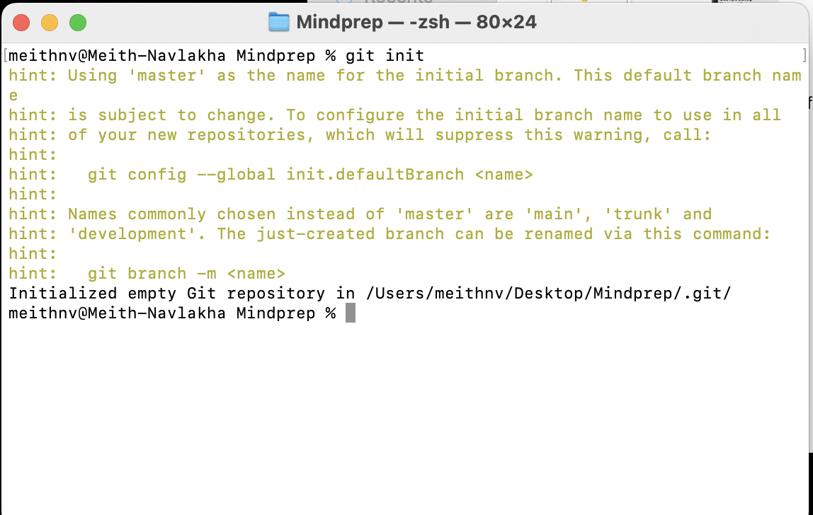

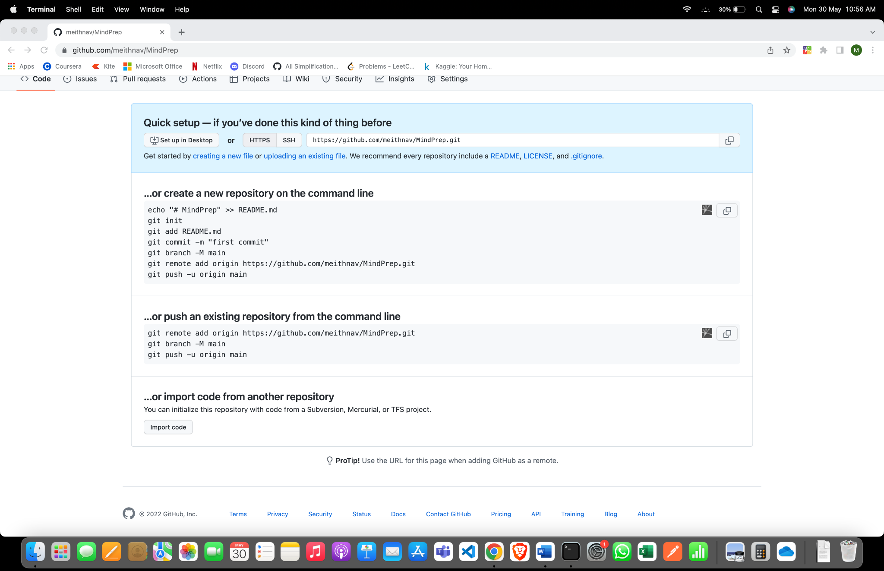

Create branch

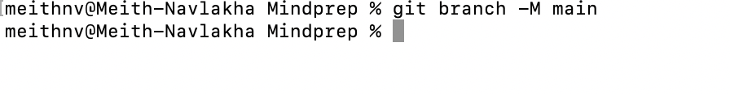

git clone

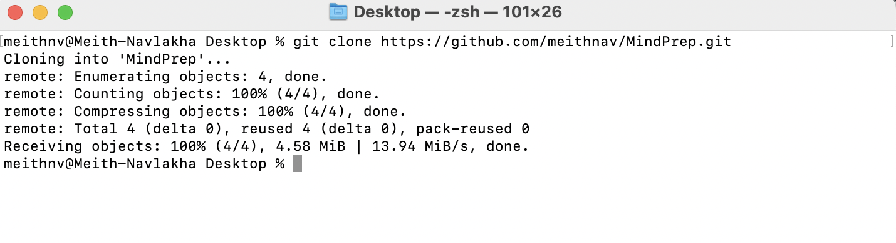

echo 'TODO:Add contents for README' > README

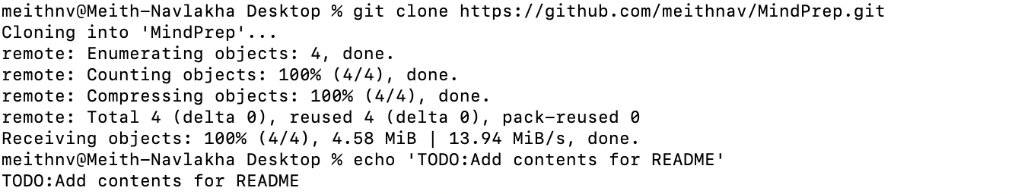

git status

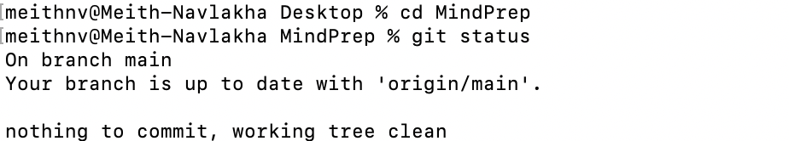

git add .

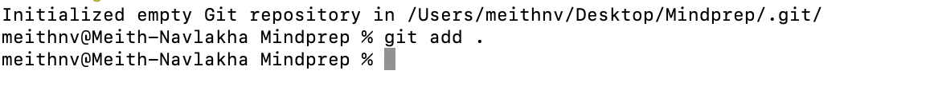

1. Generate Public-Private RSA Key Pair

|  |
| --- |
| User1@CentOS ~]$ pwd  /home/user1  [user1@CentOS ~]$ ssh-keygen |

1. Adding keys to authorized keys

Suppose there are two developers working on a project. Both users have generated public keys.

Both add their public key to the server by using ssh-copy-id command as given below

|  |
| --- |
| [user1@CentOS ~]$ pwd  /home/user1  [user2@CentOS ~]$ ssh-copy-id -i ~/.ssh/id_rsa.pub gituser@git.server.com |

1. Push changes to the repository

We have created a bare repository on the server and allowed access for two users. Both users can push their changes to the repository by adding it as a remote.

Git init command creates **.git** directory to store metadata about the repository every time it reads the configuration from the .**git/config** file.

User1 creates a new directory, adds README file, and commits his change as initial commit. After commit, he verifies the commit message by running the **git log** command.

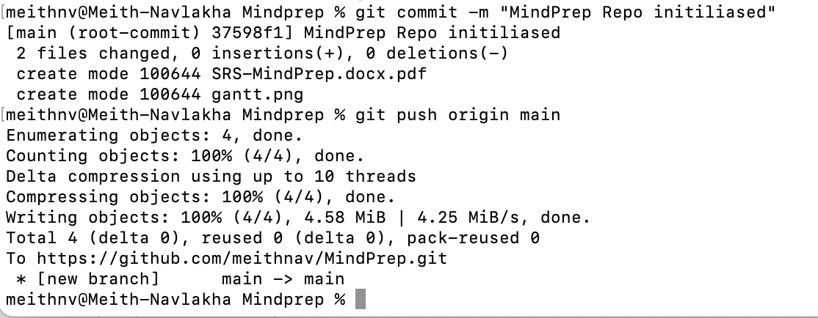

1. Checking log message by executing the git log command.



1. Commit changes

To commit the changes, he used the git commit command followed by –m option. If we omit –m option. Git will open a text editor where we can write multiline commit message



Final Repository after pushing the commit

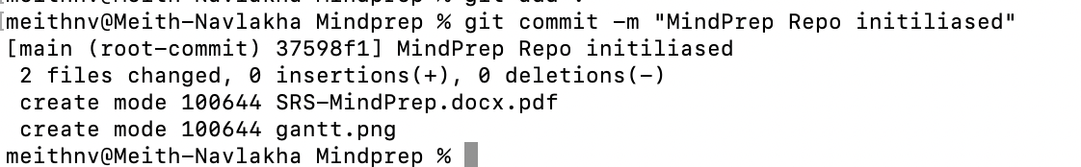

**Performance:**

1. Perform all the commands using Git
2. Take screenshots of each of the command and respective output
3. Explore the commands for merging the documents and show the screenshots.

**Conclusion:**

Configuration management using Github has been studied and different git commands have been executed. In this experiment, we have created a Github repository and commands like add, commit, push, pull, clone, echo have also been implemented. The code for the same have been observed and attached.

**SAPID:** 60004200082, 60004200066

**Names:** Pratham Bhoir, Aayushman Gupta

**Batch:** A2

**Experiment No. 8**

**Aim:** Study of Azure Devops

**Theory:**

Azure DevOps provides developer services for allowing teams to plan work, collaborate on code development, and build and deploy applications. Azure DevOps supports a collaborative culture and set of processes that bring together developers, project managers, and contributors to develop software. It allows organizations to create and improve products at a faster pace than they can with traditional software development approaches.

Azure DevOps provides integrated features that you can access through your web browser or IDE client.

**Azure Repos:**

Azure Repos is a set of version control tools that you can use to manage your code. Version control systems are software that help you track changes you make in your code over time. As you edit your code, you tell the version control system to take a snapshot of your files. The version control system saves that snapshot permanently so you can recall it later if you need it. Use version control to save your work and coordinate code changes across your team.

Azure Repos provides two types of version control:

1. Git repositories: Git is the most commonly used version control system today and is quickly becoming the standard for version control. Git is a distributed version control system, meaning that your local copy of code is a complete version control repository. These fully functional local repositories make it is easy to work offline or remotely. You commit your work locally, and then sync your copy of the repository with the copy on the server.
2. Team Foundation Version Control (TFVC): Azure Repos also supports Team Foundation Version Control (TFVC). TFVC is a centralized version control system. Typically, team members have only one version of each file on their dev machines. Historical data is maintained only on the server. Branches are path-based and created on the server.

**Azure Pipelines:**

Azure Pipelines automatically builds and tests code projects to make them available to others. It works with just about any language or project type. Azure Pipelines combines continuous integration (CI) and continuous delivery (CD) to test and build your code and ship it to any target.

Continuous Integration (CI) is the practice used by development teams of automating merging and testing code. Implementing CI helps to catch bugs early in the development cycle, which makes them less expensive to fix. Automated tests execute as part of the CI process to ensure quality. Artifacts are produced from CI systems and fed to release processes to drive frequent deployments. The Build service in Azure DevOps Server helps you set up and manage CI for your applications.

Continuous Delivery (CD) is a process by which code is built, tested, and deployed to one or more test and production environments. Deploying and testing in multiple environments increases quality. CI systems produce deployable artifacts, including infrastructure and apps. Automated release processes consume these artifacts to release new versions and fixes to existing systems. Monitoring and alerting systems run continually to drive visibility into the entire CD process.

**Azure Boards:**

Delivers a suite of Agile tools to support planning and tracking work, code defects, and issues using Kanban and Scrum methods. Azure Boards provides software development teams with the interactive and customizable tools they need to manage their software projects. It provides a rich set of capabilities including native support for Agile, Scrum, and Kanban processes, calendar views, configurable dashboards, and integrated reporting. These tools scale as your business grows.

Quickly and easily track work, issues, and code defects associated with your project. The Kanban board, shown in the following image, is just one of several tools that allows you to add, update, and filter user stories, bugs, features, and epics.

**Azure Test Plans:**

Azure Test Plans provides rich and powerful tools everyone in the team can use to drive quality and collaboration throughout the development process. The easy-to-use, browser-based test management solution provides all the capabilities required for planned manual testing, user acceptance testing, exploratory testing, and gathering feedback from stakeholders.

**Azure Artifacts:**

Azure Artifacts enable developers to consume and publish different types of packages to Artifacts feeds and public registries such as NuGet.org and npmjs.com. You can use Azure Artifacts in conjunction with Azure Pipelines to deploy packages, publish build artifacts, or integrate files between your pipeline stages to build, test, or deploy your application.

**Azure Architecture Solutions:**

1. Azure Architecture for Content based Recommendation System:

This example scenario covers the training, evaluation, and deployment of a machine learning model for content-based personalization on Apache Spark using Azure Databricks. In this case, a model is trained with a supervised classification algorithm on a dataset containing user and item features. The label for each example is a binary value indicating that the user engaged with (for example, clicked) an item. This scenario covers a subset of the steps required for a full end-to-end recommendation system workload. The broader context of this scenario is based on a generic e-commerce website with a front end that serves rapidly changing content to its users. This website uses cookies and user profiles to personalize the content for that user. Along with user profiles, the website may have information about every item it serves to each user.

1. Azure Architecture for Distributed Training Deep learning models:

This reference architecture shows how to conduct distributed training of deep learning models across clusters of GPU-enabled VMs. The scenario is image classification, but the solution can be generalized to other deep learning scenarios such as segmentation or object detection.

**Workflow**

This architecture consists of the following services:

**Azure Machine Learning Compute** plays the central role in this architecture by scaling resources up and down according to need. Azure ML Compute is a service that helps provision and manage clusters of VMs, schedule jobs, gather results, scale resources, and handle failures. It supports GPU-enabled VMs for deep learning workloads.

**Standard Blob storage** is used to store the logs and results. Premium Blob storage is used to store the training data and is mounted in the nodes of the training cluster using blobfuse. The Premium tier of Blob storage offers better performance than the Standard tier and is recommended for distributed training scenarios. When mounted using blobfuse, during first the epoch, the training data is downloaded to the local disks of the training cluster and cached. For every subsequent epoch, the data is read from the local disks, which is the most performant option.

**Container Registry** is used to store the Docker image that Azure Machine Learning Compute uses to run the training.

1. Azure Architecture for CI/CD:

Azure Web Apps is a fast and simple way to create web apps using ASP.NET, Java, Node.js, or PHP. Deliver value faster to your customers with a continuous integration and continuous deployment (CI/CD) pipeline that pushes each of your changes automatically to Web Apps.

**Conclusion:**

Azure DevOps provides developer services for allowing teams to plan work, collaborate on code development, and build and deploy applications. Azure Pipelines automatically builds and tests code projects to make them available to others. Azure Machine Learning Compute plays the central role in this architecture by scaling resources up and down according to need.